Quarantine Reference Manual
Being directed to quarantine is indicative of being in direct exposure to someone who tested positive for COVID-19. Quarantine typically lasts for a period of 14 days.
It is not permitted to leave quarantine housing before you are released from quarantine by the COVID Response Coordinator. If it is necessary to leave quarantine prior to the indicated release date, you must alert Residence Life (406.791.5225) and let them know of your planned departure. Note that you may NOT enter the residence halls or other campus buildings before your scheduled quarantine release date issued by the COVID Response Coordinator
In Your Quarantine Room
- You are welcome to be mask-free while in your personal rooms with the door closed.
- No one else is allowed in your room.
- Follow the basic rules and guidelines of the residence halls.
- Each resident may be issued a temporary electronic device if they do not have their own device. This device can be used for the purpose of completing required coursework.
- A representative from Alluvion Health will be checking in with you (medically) daily during your time in quarantine. If, at any time, you would like to talk to a medical provider, you may contact Alluvion 24/7 and a medical professional will assist you. The number is 406-454-6973.
- A representative from the Office of Mission Integration will check in with you (non-medically) frequently for the duration of your stay in quarantine. The intent of this contact is to offer support in any avenue of non-medical needs such as: spirituality, tutoring, counseling, etc. If you need support in the case of a personal emergency please contact 406-791-5261.
Outside Your Quarantine Room
- You must wear a mask when you leave your room, to access any other area of the facility.
- Visitors are NOT permitted to be in any area of the quarantine building.
- Wash your hands often.
- Do not leave toiletry items in the bathroom - take them with you to and from your room.
- You may share the kitchen space, laundry space, and exercise space and equipment with other quarantined students while wearing a mask and maintaining physical distance of 6 feet or more. It is critically important to follow cleaning protocols by wiping down high touch surfaces when you enter an area and when you leave an area. You must wipe down exercise equipment with a sanitizing wipe prior to use of the equipment and again once your workout is complete.
- Keep shared spaces clean.
- Utilize exercise equipment in the common space of the building, as health permits.
- Snacks and refreshments will be stocked in the shared kitchenette located on the main floor of the building. Please feel free to take items as needed.
Outside the Building
- You may use the outdoor space by your building.
- You should not leave the quarantine site or the designated outdoor space until you have been released from directed quarantine by the COVID Response Coordinator or unless it has been cleared with the Residence Life office.
- In the case of medical appointments or emergencies, leaving the quarantine site is permitted. Please use proper precautions during your time away from campus.
Food
- Food will be delivered to your building during normal meal times.
- If you are quarantined your COVID coordinator will work with you on weekly meal orders during your check-in to your quarantine room.
- Food deliveries from any entity other than food services is not permitted.
Mail
- Mail will be delivered to your building during normal business hours.
Laundry
- Laundry services are available in the quarantine facility. Please use the space as any other shared space, by wearing a mask and distancing from others, and wiping down high touch surfaces at the beginning and end of your personal use.
Academics
- You will be required to attend classes virtually, if your health permits doing so.
- Faculty will be notified of your inability to participate in any face-to-face courses, but we will not disclose the purpose for not attending.
Leaving Directed Quarantine
- After 14 days, 24 hours symptom-free (without fever reducing medications), and with approval of the COVID Response Coordinator, you may return to normal activity at 8 a.m. the following day. At that time, you will be required to return to in-person classes.
- When leaving your quarantine room, take all your items, place sheets and towels on the bed, place trash outside the door and leave the building fob, and room key on the desk in the room.
- The COVID Response Coordinator will notify housing of your release date. Housing will have your student ID card reactivated for access to Argo Hall or will provide you your FOB for access to Emilie Hall to move back into your originally assigned residential room.
- Personnel are available to assist you with your move from isolation to your originally assigned residential room. If you would like assistance, please call 406.781.0987.
Failure to follow these expectations will result in disciplinary action. It is your responsibility to contact Residential Life for any questions regarding these expectations.

CONTACT INFORMATION
Housing:
Jeddie Herndon, Director of Residential Life – 406.791.5225
jeddie.herndon@uprovidence.edu or housing.up@uprovidence.edu
Academics:
Contact your professor or advisor (number typically found on syllabus)
Or
Contact your Academic Success Counselor (Twila 406-791-5988) (Hayley 406-791-5228) (Ellen 406-791-5987)
COVID or Medically Related Health Questions:
Alluvion Health
24/7 Medical Provider Contact – 406-454-6973
or
UP Health Clinic (Monday-Friday, 7:00am – 10:00am) – 406-791-5231
or
Head Athletic Trainer
Monica Thackery – 406.791.5937 or monica.thackery@uprovidence.edu
Courtney Rayfield – 406-791-5938 or courtney.rayfield@uprovidence.edu
Morgan Olsen – 406-791-5943 or morgan.olsen@uprovidence.edu
Brad Beffert – 406-791-5923 or brad.beffert@uprovidence.edu
Facilities / Maintenance:
Physical Plant – 406.791.5283
Tech Support:
Service Desk - 406.791.5326 or servicedesk@uprovidence.edu
Parent inquires and all else:
Dean of Students,
Jake Clark – 406.791.5230
jake.clark@uprovidence.edu
Emergencies:
911
Resident Assistant, Duty Phone:
406.781.0987

ROOM SERVICES AND NEEDS

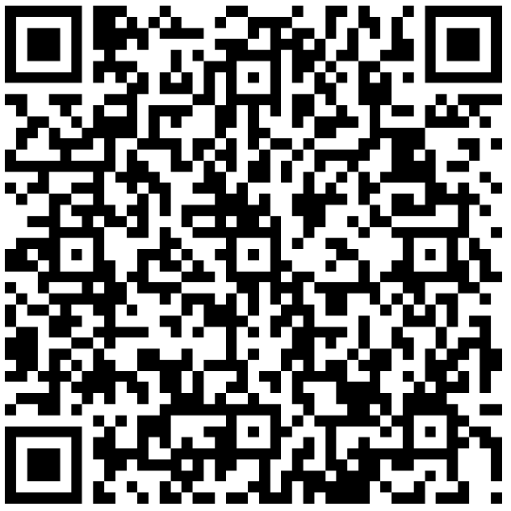
Please let us know if you need any restocking of items for your room, including (but not limited to):
- New towels
- New bedding
- Garbage bad liners
- Dish soap
- Toiletries
Likewise, if there are services of support that you need, please use this QR code to let us know. Services include (but are not limited to):
- Mental health support
- Spiritual care
- Academic support

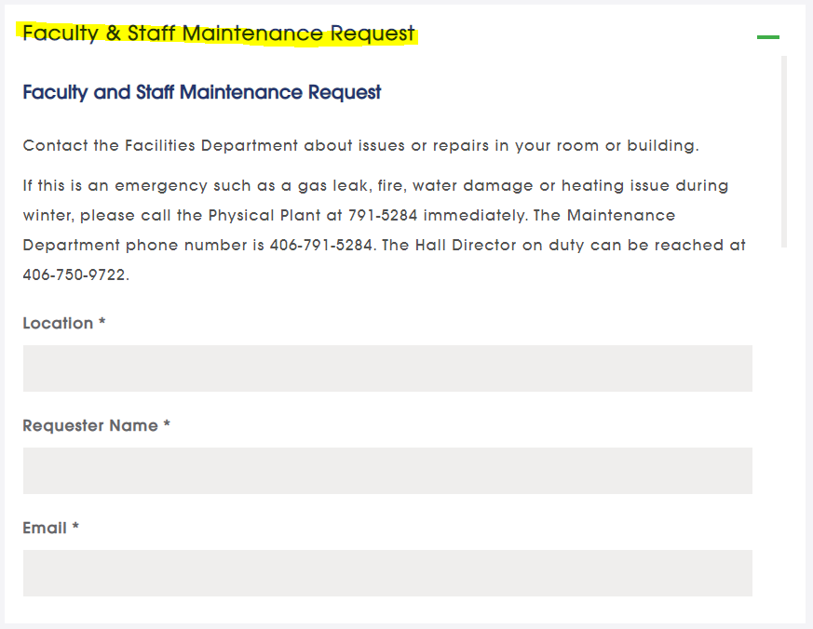
MAINTENANCE REQUESTS AND NEEDS
https://www.uprovidence.edu/about/facility-rentals/
Have any issues or repairs needed to be addressed in your room? Contact Facilities and they will be glad to assist!
Emergency (non-medical): 406-791-5284
Non-medical, non-emergency: 406-791-5284

