Isolation Reference Manual

Being in isolation indicates that you have tested positive for COVID-19. Isolation lasts for at least 10 days. Before release, you must first be assessed and given authorization for release.
It is not permitted to leave isolation housing before you are released from isolation by the COVID Response Coordinator. If it is necessary to leave isolation prior to the indicated release date, you must alert Residence Life (406.791.5225) and let them know of your planned departure. Note that you may NOT enter the residence halls or other campus buildings before your scheduled release date by the COVID Response Coordinator.

In Your Isolation Room
- You are welcome to be mask-free while in your personal rooms with the door closed.
- No one else is allowed in your room.
- Follow the basic rules and guidelines of the residence halls.
- Each resident may be issued a temporary electronic device if they do not have their own device. This device can be used for the purpose of completing required coursework.
- A representative from Alluvion Health will be checking in with you (medically) daily during your time in isolation. If, at any time, you would like to talk to a medical provider, you may contact Alluvion 24/7 and a medical professional will assist you. The number is 406-454-6973.
- A representative from the Office of Mission Integration will check in with you (non-medically) frequently for the duration of your stay in quarantine. The intent of this contact is to offer support in any avenue of non-medical needs such as: spirituality, tutoring, counseling, etc. If you need support in the case of a personal emergency please contact 406-791-5261.
- Snacks and refreshments will be stocked in your assigned room; please help yourself to those items.
Outside Your Isolation Room
- It is requested that you stay in your room for the duration of your time in isolation. The only exception for leaving your assigned room, would be for the use of laundry facilities in the building, or for the purpose of emergent medical appointments, or for medical emergencies.
- You must wear a mask when you leave your room.
- Visitors are NOT allowed.
- Wash your hands often.
- You may not gather in shared spaces, such as the lounge, with other students in isolation.
Outside Your Isolation Building
- We understand that staying isolated and away from others is abnormal. Under the circumstances, it is in the best interest of you and others, to do so.
- You may not leave the isolation site or the designated outdoor space until you have been released from directed isolation by the COVID Response Coordinator or unless it has been cleared with the Residential Life office.
Food
- Food will be delivered to your building during normal meal times.
- If you are quarantined your COVID coordinator will work with you on weekly meal orders during your check-in to your quarantine room.
- Food deliveries from any entity other than food services is not permitted.
Mail
- Mail will be delivered to your building during normal business hours.
Laundry
- Laundry services are available in the isolation facility. Please use the space as any other shared space, by wearing a mask and distancing from others, and wiping down high touch surfaces at the beginning and end of your personal use.
Academics
- You will be required to attend classes virtually, if your health permits doing so.
- Faculty will be notified of your inability to participate in any face-to-face courses, but we will not disclose the purpose for not attending.
Leaving Isolation
- After 10 days, 24 hours symptom-free (without fever reducing medications), and with approval of the COVID Response Coordinator, you may return to normal activity at 8 a.m. the following day. At that time, you will be required to return to in-person classes.
- When leaving your isolation room, take all your items, place sheets and towels on the bed, place trash outside the door.
- The COVID Response Coordinator will notify housing of your release date. Housing will have your student ID card reactivated for access to Argo Hall or will provide you your FOB for access to Emilie Hall to move back into your originally assigned residential room.
- Personnel are available to assist you with your move from isolation to your originally assigned residential room. If you would like assistance, please call 406.836.0672.
Failure to follow these expectations will result in disciplinary action. It is your responsibility to contact Residential Life for any questions regarding these expectations.

CONTACT INFORMATION
Housing:
Jeddie Herndon, Director of Residential Life – 406.791.5225
jeddie.herndon@uprovidence.edu or housing.up@uprovidence.edu
Academics:
Contact your professor or advisor (number typically found on syllabus)
Or
Contact your Academic Success Counselor (Twila 406-791-5988) (Hayley 406-791-5228) (Ellen 406-791-5987)
COVID or Medically Related Health Questions:
Alluvion Health
24/7 Medical Provider Contact – 406-454-6973
or
UP Health Clinic (Monday-Friday, 7:00am – 10:00am) – 406-791-5231
or
Head Athletic Trainer
Monica Thackery – 406.791.5937 or monica.thackery@uprovidence.edu
Courtney Rayfield – 406-791-5938 or courtney.rayfield@uprovidence.edu
Morgan Olsen – 406-791-5943 or morgan.olsen@uprovidence.edu
Brad Beffert – 406-791-5923 or brad.beffert@uprovidence.edu
Facilities / Maintenance:
Physical Plant – 406.791.5283
Tech Support:
Service Desk - 406.791.5326 or servicedesk@uprovidence.edu
Parent inquires and all else:
Dean of Students,
Jake Clark – 406.791.5230
jake.clark@uprovidence.edu
Emergencies:
911
Resident Assistant, Duty Phone:
406.836.0672

CONTACT INFORMATION
Housing:
Jeddie Herndon, Director of Residential Life – 406.791.5225
jeddie.herndon@uprovidence.edu or housing.up@uprovidence.edu
Academics:
Contact your professor or advisor (number typically found on syllabus)
Or
Contact your Academic Success Counselor (Twila 406-791-5988) (Hayley 406-791-5228) (Ellen 406-791-5987)
COVID or Medically Related Health Questions:
Alluvion Health
24/7 Medical Provider Contact – 406-454-6973
or
UP Health Clinic (Monday-Friday, 7:00am – 10:00am) – 406-791-5231
or
Head Athletic Trainer
Monica Thackery – 406.791.5937 or monica.thackery@uprovidence.edu
Courtney Rayfield – 406-791-5938 or courtney.rayfield@uprovidence.edu
Morgan Olsen – 406-791-5943 or morgan.olsen@uprovidence.edu
Brad Beffert – 406-791-5923 or brad.beffert@uprovidence.edu
Facilities / Maintenance:
Physical Plant – 406.791.5283
Tech Support:
Service Desk - 406.791.5326 or servicedesk@uprovidence.edu
Parent inquires and all else:
Dean of Students,
Jake Clark – 406.791.5230
jake.clark@uprovidence.edu
Emergencies:
911
Resident Assistant, Duty Phone:
406.781.0987

ROOM SERVICES AND NEEDS

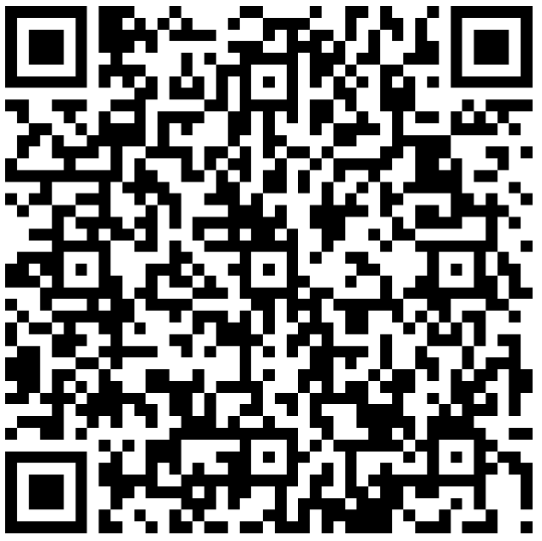
Please let us know if you need any restocking of items for your room, including (but not limited to):
- New towels
- New bedding
- Garbage bad liners
- Dish soap
- Toiletries
Likewise, if there are services of support that you need, please use this QR code to let us know. Services include (but are not limited to):
- Mental health support
- Spiritual care
- Academic support

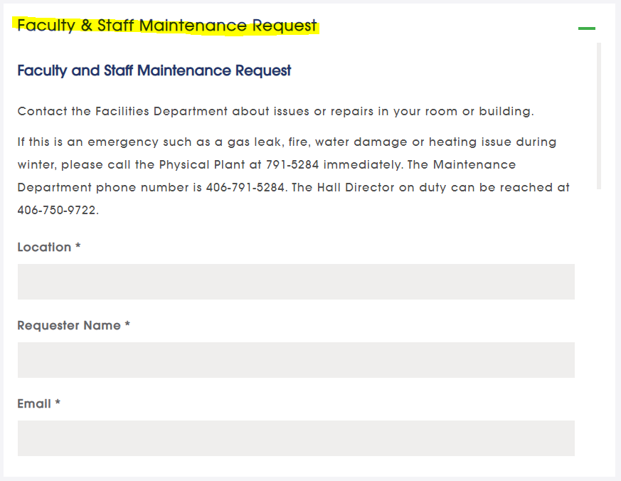
MAINTENANCE REQUESTS AND NEEDS
https://www.uprovidence.edu/about/facility-rentals/
Have any issues or repairs needed to be addressed in your room? Contact Facilities and they will be glad to assist!
Emergency (non-medical): 406-791-5284
Non-medical, non-emergency: 406-791-5284

