Fans in the Stands
The University of Providence has 200+ seats in McLaughlin Center. As we start the sporting season, we are projected to NOT have any fans attend any contest.
In an attempt to have the game day experience for our student athletes, I am asking you to help support our Argos, for a $100 donation you will receive a personal cardboard cutout in those seats.
The donation will include one cutout with the remainder of the money to be used for “branding as needed throughout the Athletics Dept”
Rules for cardboard cutouts include: it cannot be someone famous, it cannot violate trademark rules, and we prefer to have pictures wearing Argo gear or older school gear. You can pick yourself, a friend (if they give permission), or your pet. We will need a high-resolution picture of you or the subject you wish to be in your seat.
FAN CARDBOARD CUT-OUTS
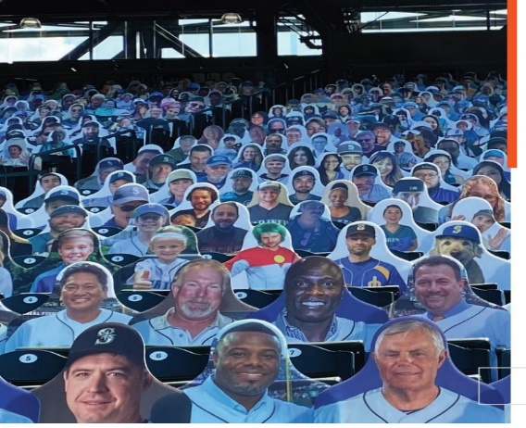

Support the Argos and sign up today!

Name: _________________________________ Address: ______________________________________

How Many Seats: ______________________ X $100.00 = Total: _________________________________

Please sign up before December 12, 2020

Invoices will be sent

