ArgoMail Instructions

ArgoMail is the official University of Providence email system. It will be used for all official campus and class communications.

- You can access your ArgoMail from a home page link on the official website of the University at http://www.uprovidence.edu or from any web browser and Internet service using the following address: www.office.com.

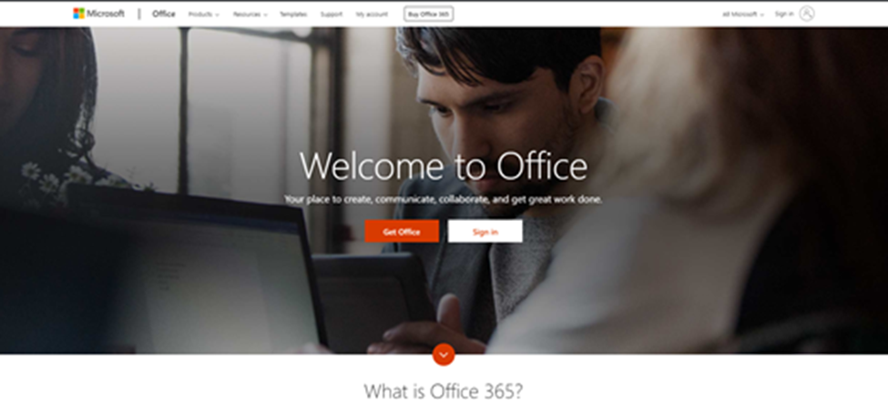
- Click on Sign in
- Type your username, password and click Next
- Your ArgoMail account logon and address: username@uprovidence.edu

- Default Password: F (1st initial -uppercase) + l (last initial – lowercase) + MMDDYYYY(birth date) + !!

Example: Mickey Mouse born July 4th 1776 = Mm07041776!!

If you changed your account password on a campus computer, then you have changed your ArgoMail/Office365 password

As with all passwords, keep your email password secure. You are responsible for all activity associated with this account.

- You will now be required to provide more information and start enrolling your device against your Office 365 account using the Office 365 MFA Step-by-Step Setup

ArgoMail Instructions - Office 365 MFA Step-by-Step Setup

- Click Next in the screen below

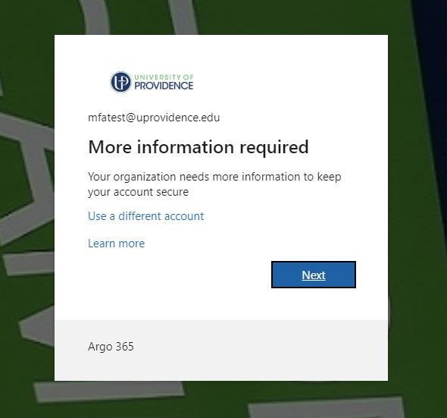
You will be required to setup either the Microsoft Authenticator App OR use a phone PIN. See steps below for instructions.

ArgoMail Instructions - Office 365 MFA Step-by-Step Setup
Method 1: Microsoft Authenticator
You will now be presented with a wizard to install the Microsoft Authenticator app on your phone
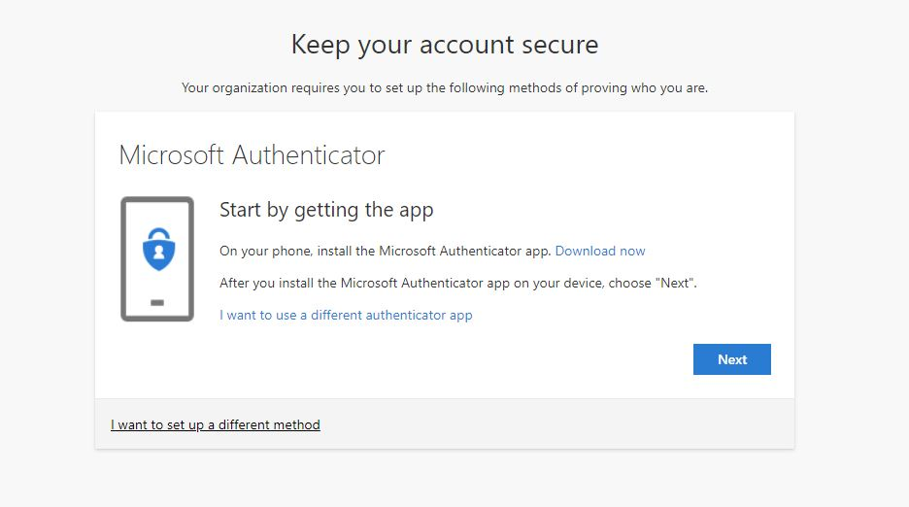

ArgoMail Instructions - Office 365 MFA Step-by-Step Setup

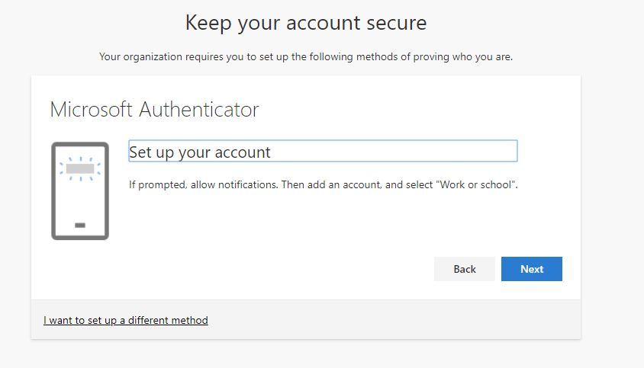

Once you have downloaded the app, please make sure you allow the Microsoft Authenticator app to use your camera (if asked).
If the app cannot use the camera, you will not be able to complete the setup correctly.
Once the app is installed, you will need to set up your account to connect to the app.

ArgoMail Instructions - Office 365 MFA Step-by-Step Setup

You will receive a unique QR code from Microsoft in your email account.

This is only an example and will not work for your account:
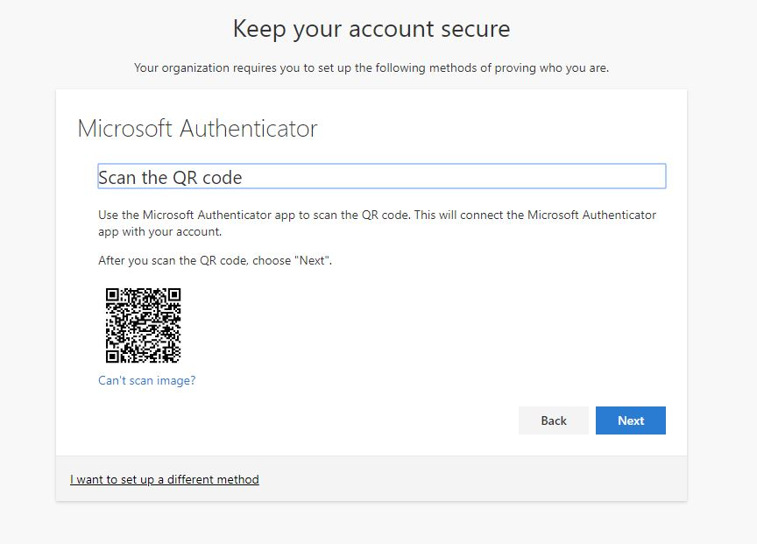

ArgoMail Instructions - Office 365 MFA Step-by-Step Setup

Now that the app has been registered against your account, let’s validate that it has been set up correctly
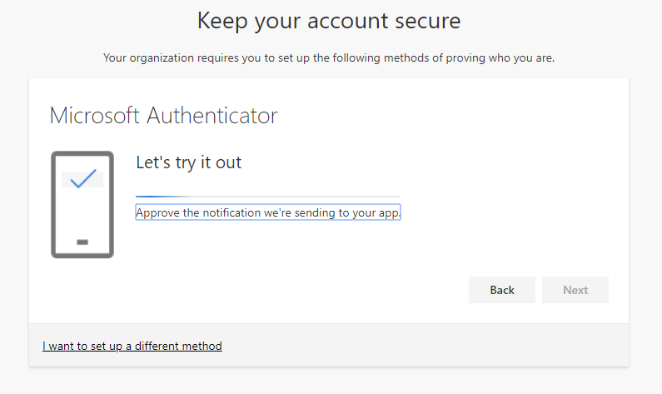
You will receive a ‘pop up’ notification from Microsoft Authenticator. You will need to press the Approve button to move forward. The nice thing, compared to SMS MFA is that you do not have to type any number, making the process faster and easier.
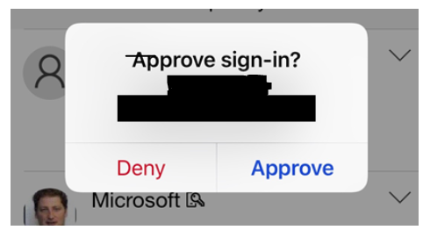

ArgoMail Instructions - Office 365 MFA Step-by-Step Setup

If the setup is successful, you will receive the following confirmation – Notification approved

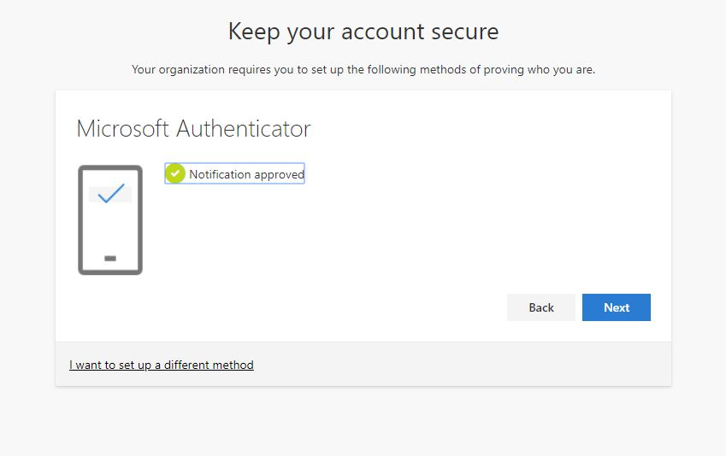
Click Next then Done

ArgoMail Instructions - Office 365 MFA Step-by-Step Setup

Method 2: Phone PIN Code (SMS)

Select “I want to set up a different method” and then choose the Phone option in the drop-down.

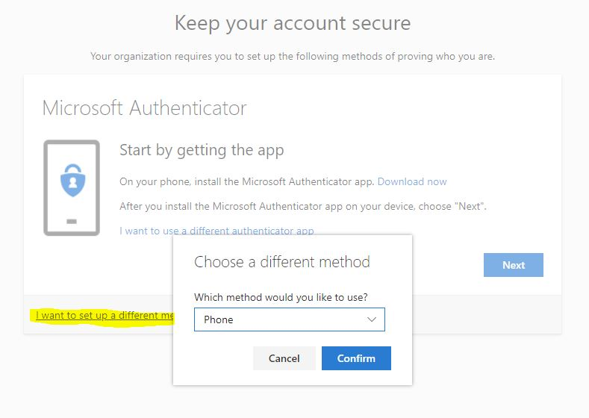

ArgoMail Instructions - Office 365 MFA Step-by-Step Setup
In the example below, I have chosen the SMS option. Once you receive the SMS, enter it and click Next
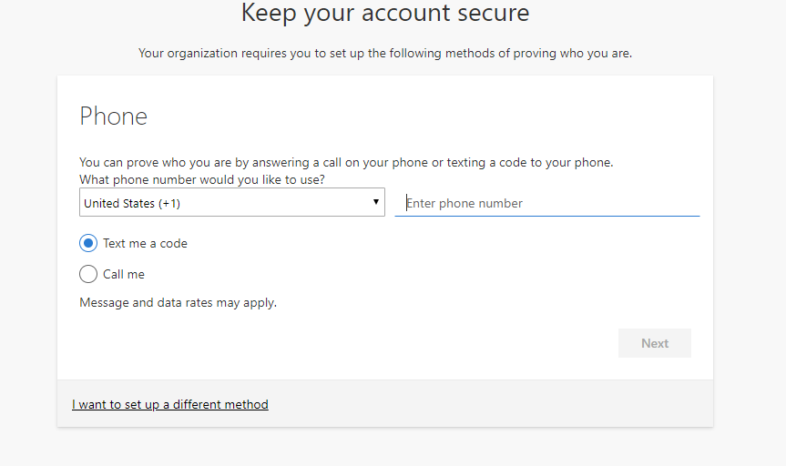
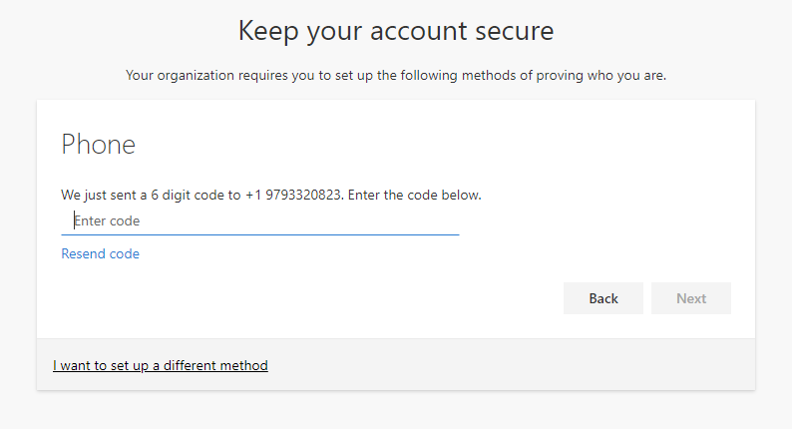

ArgoMail Instructions - Office 365 MFA Step-by-Step Setup

When successful, you will receive the following screen “SMS verified successfully”

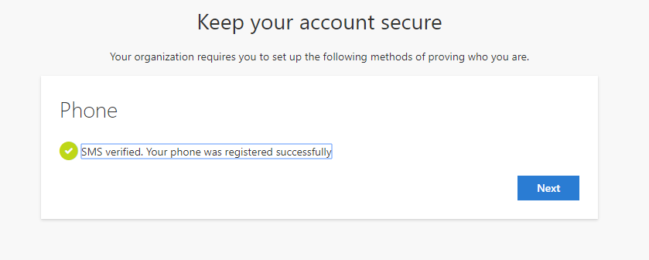
Click Next and then Done.

ArgoMail Instructions – Change Password

Change Office365/ArgoMail Password within Web Email

- After setting up your Office365 settings, you will land on the Welcoming Apps page
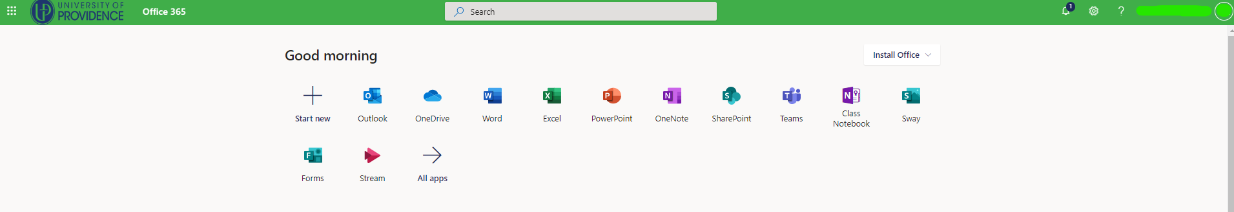
- Click on the Settings Gear in the upper right-hand corner
- Select Change your Password
- In resetting your password
  - You will need to enter your existing password
  - Enter a new password
    - (Requirements: 12 or more characters that include at least one of each: an uppercase letter (A-Z), a lowercase letter (a-z), a number (0-9), and a special character (! - *)
  - Confirm your new password.

If you need further assistance, please contact ServiceDesk@uprovidence.edu for assistance or call the UP ServiceDesk at 406.791.5326

